Participatory Landscape Assessment at Sakri Panchayat, Baijnath, Kangra, Himachal Pradesh

Exercise: Natural Resource Status

Objective:
To understand the status of the Natural Resources within the Sakri Panchayat.

Facilitators:
WASSAN Team: A Ravindra & Chhavi
RTDC Team: Dr. D. K. Sadana, Sanjay Ji, Meena Ji and Rama Ji

Documentation:
Sai Nikam, Diksha Alok

Participants:
Sukarna | Bharadi | Khas Sakri | Lower Sakri | Baba Kathak | Total
22 | 15 | 12 | 5 | 4 | 58

To initiate the discourse on the status of Natural Resources, the following questions led us to the exercise’s core.
Q: Can a household survive on its own?
A: It is difficult for a household to survive alone. Interaction with the surrounding environment is necessary.
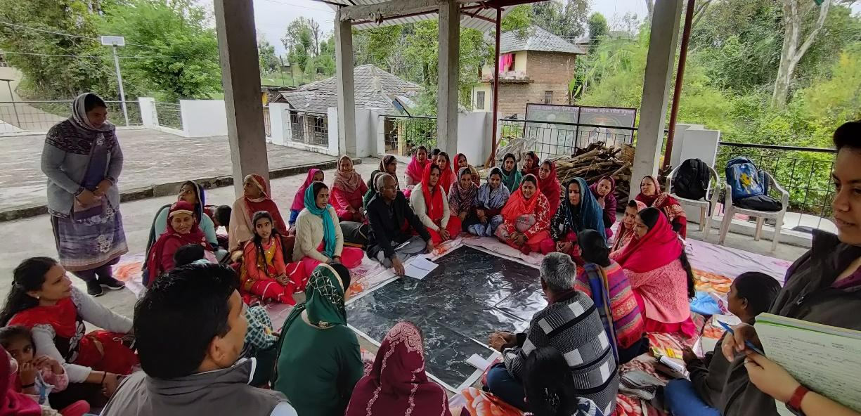
Picture 1. Shows the initial conversation with the community people.
Q: What are the things that you are dependent upon within the community, environment and larger society?
A: Family, Forest, Agricultural land, Buyers and sellers, good health, good seeds, schools, banks, hospitals, temples, Panchayat, Water, Neighbourhood, Quality Air, Animals, Jobs, Stores, houses, and Electricity.
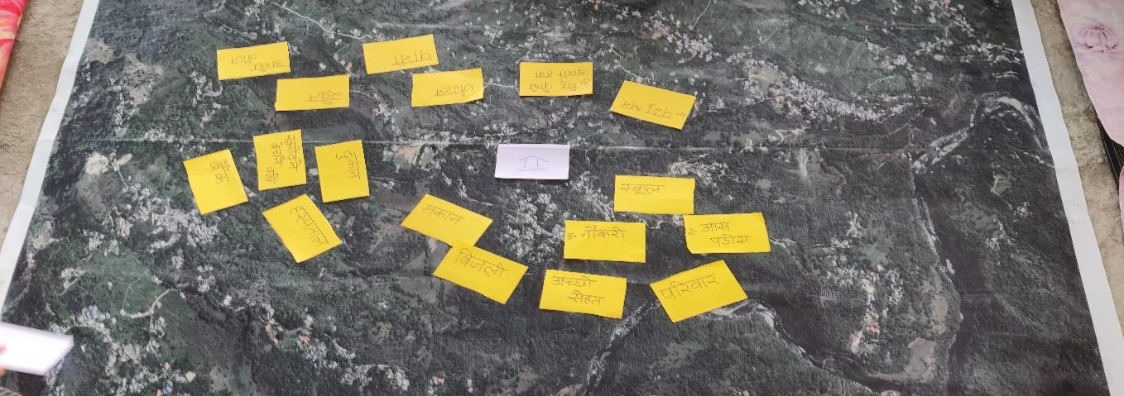
Picture 2: Shows the dependency of a household on the community, environment and society
Q: How will you categorise your dependency in the following: Social Relations, Natural Resources, Economy, Other services
Social relations | Natural resources | Economy | Other services
Family | Livestock | Jobs | Electricity
House | Water | Shops | Schools
Neighbourhood | Forest | Buyers and sellers | Hospitals
Good health | Plants and fresh air | Banks
 | Agricultural Land
 | Soil
 | Seeds
Table 1:Shows how the community categorises their dependency on a)Social Relations, b)Natural Resources, c)Economy and d)Other services
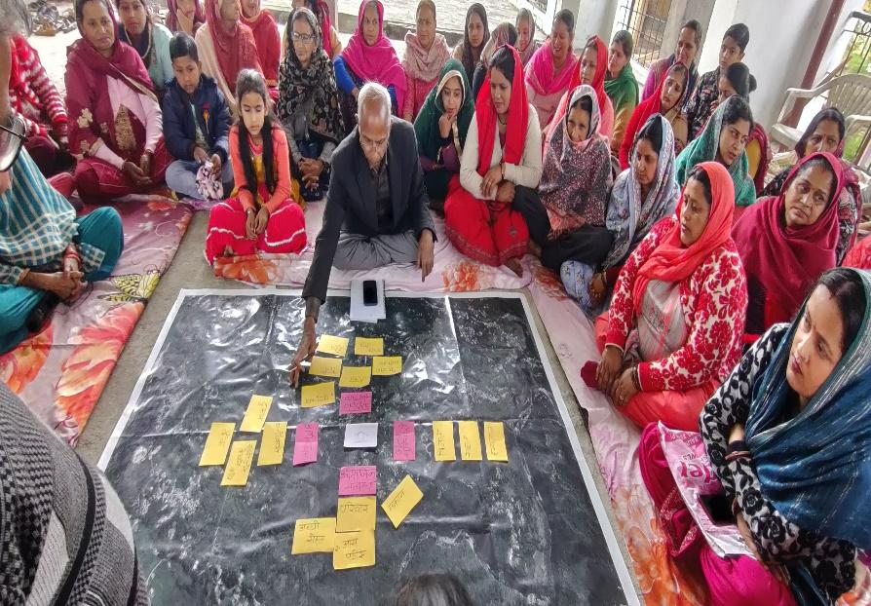
Picture 3: Shows how the community categorised their dependency on a) Social Relations, b) Natural Resources, c) Economy and d) Other services
Q. How would you assess a good village?
A: The community set the following parameters to assess a village as a good village: 1. Cleanliness, 2. Good Roads, 3. Electricity, 4. Water, 5. Good behaviour, 6. Hospital/PHC, 7. Marketable surplus, 8. NTFP, 9. Employment, 10. Organic / NF, 11. Forest, 12. Good soil
Q: Based on your assessment, how much will you score your village (Panchayat as a whole) in terms of natural resources, i.e. Plants and Clean air, Forest, Water, Livestock, Agricultural Land, Soil and Seeds?
Based on their understanding, the groups from each hamlet of the Sakri Panchayat scored the Natural Resources.
 | Sakri Bharadi | Sukarna | Lower Sakri | Baba Kathak | Khas Sakri
Plants and Clean Air | 5 | 5 | 10 | 10 | 10
Forest | 10 | 9 | 10 | 10 | 10
Water | 7 | 1 | 7 | 0 | 5
Livestock | 10 | 7 | 7 | 7 | 8
Agricultural Land | 5 | 8 | 10 | 5 | 5
Soil | 7 | 10 | 7 | 8 | 5
Seeds | 8 | 6 | 5 | 5 | 2
Table 2: Shows the scores given by the community to their Natural Resources
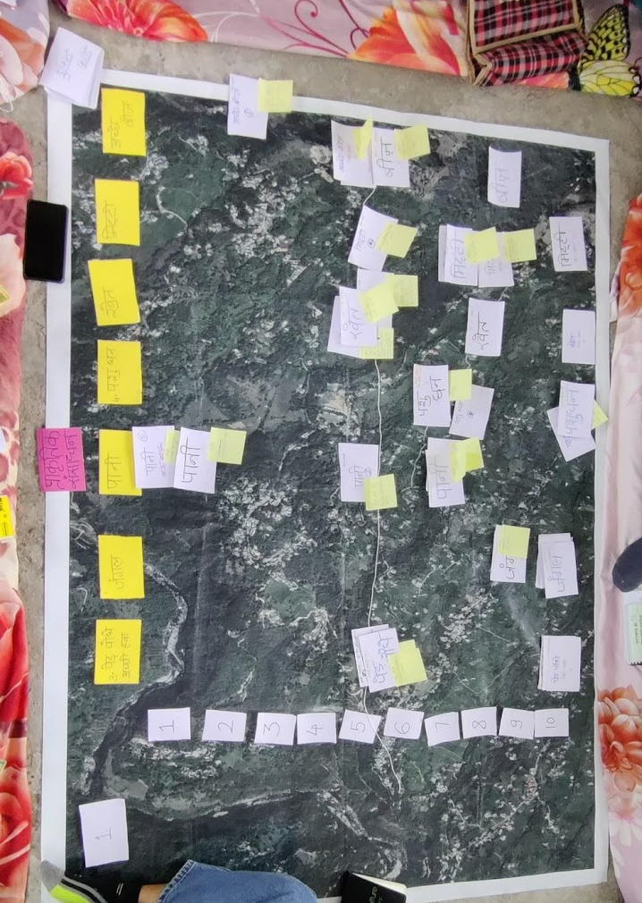
Picture 4: Shows the scores the groups gave to the natural resources surrounding their hamlets

To conclude the following exercise, the data was presented in a Spider Diagram, which shows the status of the natural resources within the Sakri Panchayat.
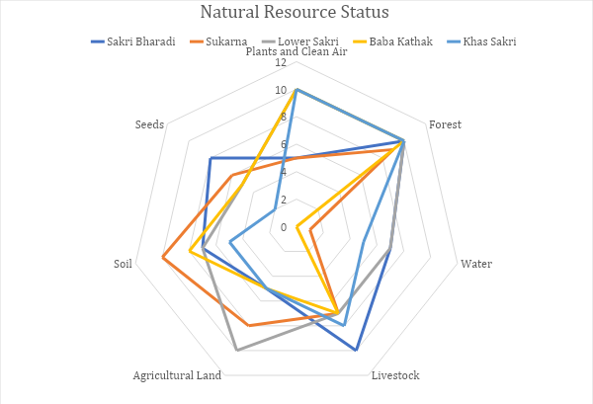

Major issues faced by communities were as follows,
- Feral cattle, along with wild animals such as Nilgai, Monkeys, Langurs and wild boars, have been damaging crops, due to which farmers have stopped cultivating land and acreage left fallow is increasing year on year.
- As weather patterns become increasingly unpredictable, dependence on irrigation for water has increased. But due to the lack of an organised irrigation system, farmers are unable to get a high yield.
- Over the years, indigenous seeds have been replaced by improved or hybrid varieties. Local markets are not always able to provide good quality seeds, which impacts the yield quality.
- The easy availability and affordability of chemical inputs as compared to bio-inoculants make it difficult to reduce the dependency of farmers on chemicals.

